**Displaying User Feedback**

**Screenshot**

**Feedback.java**

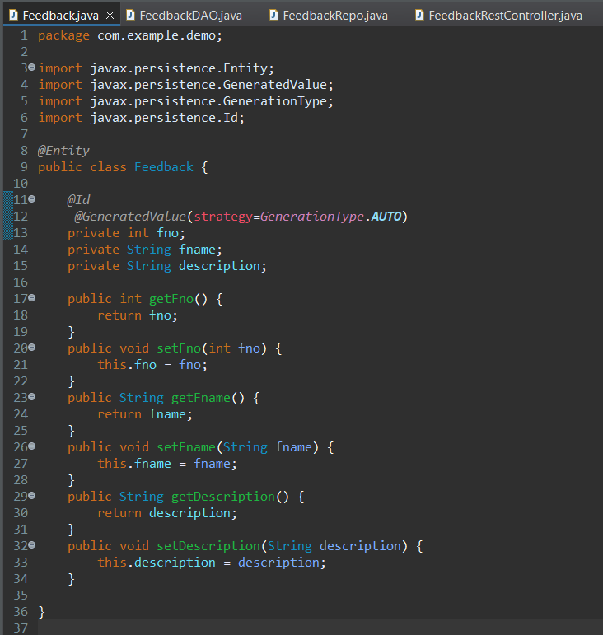

**FeedbackDAO.java**

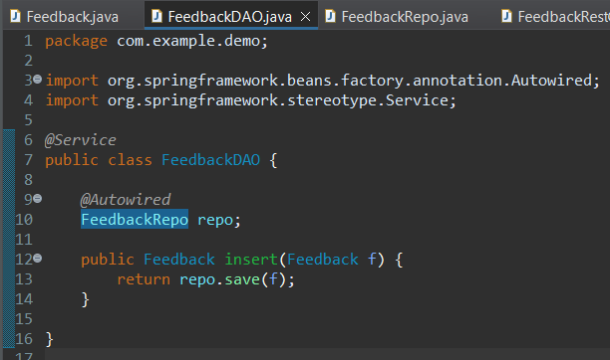

**FeedbackRepo.java**

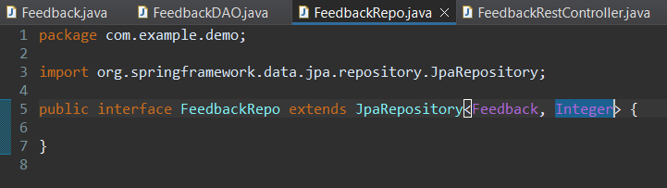

**FeedbackRestController.java**

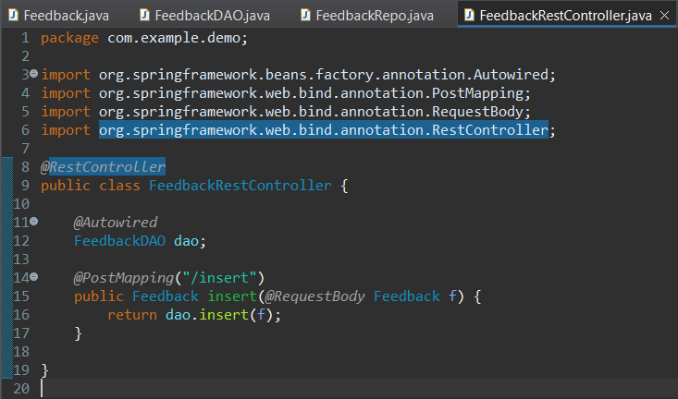

**application.properties**

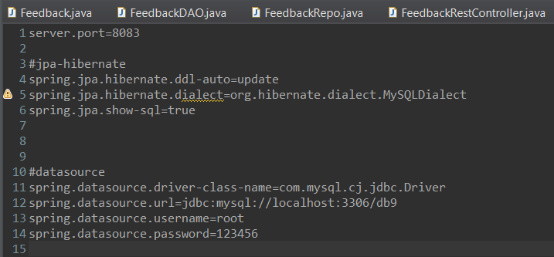

**OUTPUT**

